**Understanding Doc for Langchain Concepts**

# **Vector Store and Vector Embeddings**

Let’s look closely at what a vector store and vector embeddings are. A vector store is used to store data in the form of vector embeddings. Vector Embeddings are numerical representations of source data that capture the meaning and relationship of words, phrases and other data types.

For example, the vector embeddings for “dog” and “puppy” would be close together because they share a similar meaning and often appear in similar contexts.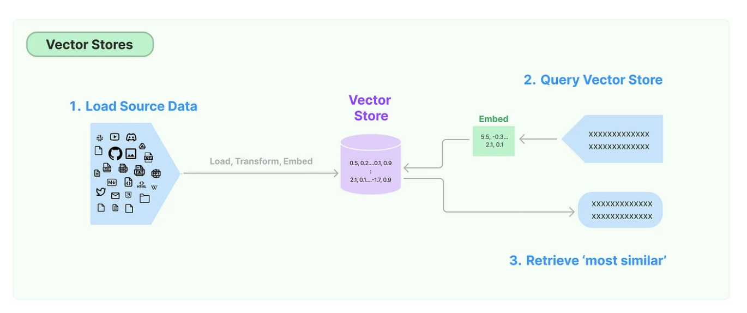

**Process of creating vector embeddings and inserting into vector store**

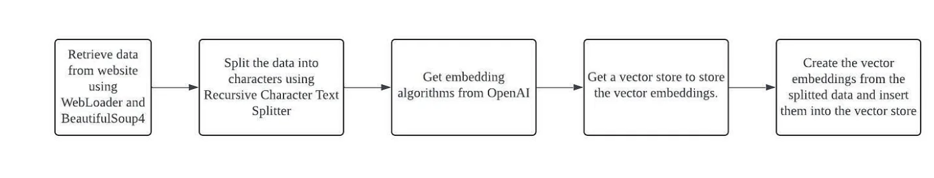

# **Creating a Retrieval Chain**

Of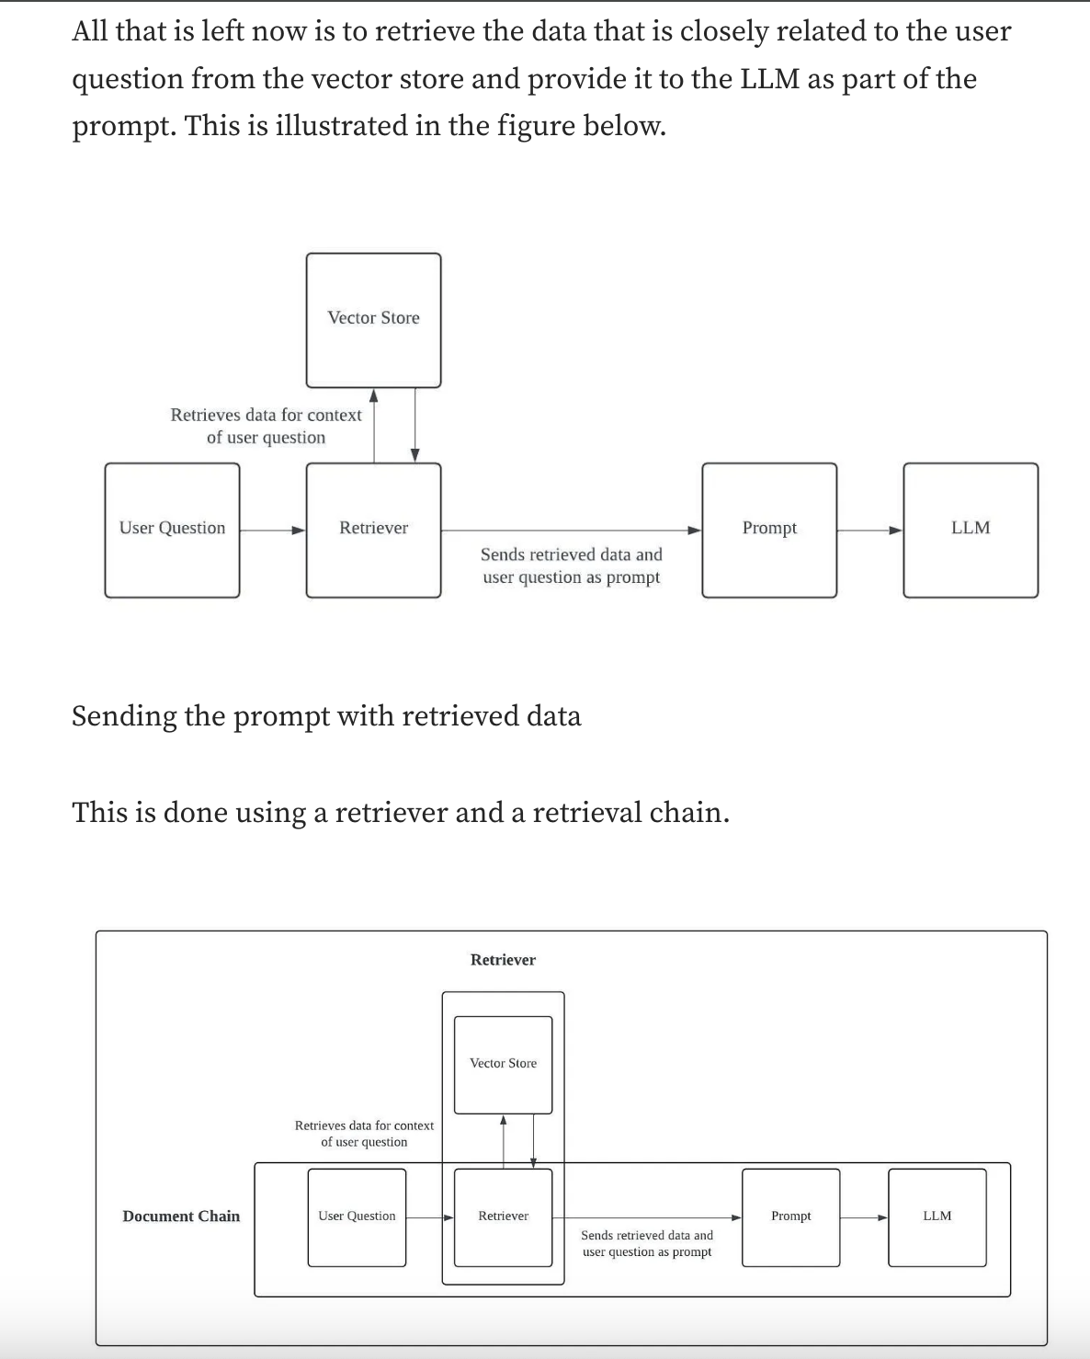

To sum it up, the Retrieval Chain from LangChain uses the input question to retrieve the relevant data from a vector store, and sends only the relevant data as context along with the user question to the LLM. This enables a large amount of data to be used as context for the LLM.

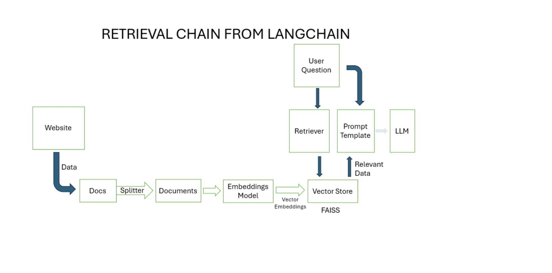

Reference : <https://vijaykumarkartha.medium.com/multiple-ai-agents-creating-multi-agent-workflows-using-langgraph-and-langchain-0587406ec4e6>

**Summarize above search process:-**

**This is the base of any search**

## **Splitting the document in smaller chunks**

## **Converting chunks into embeddings**

## **Performing a similarity search on the embeddings**

* 1. Similarity search on embeddings helps us find articles, paragraphs, or sentences that are closely related to the question at hand

1. **Generate answers to questions using an LLM**
   1. Once the most similar chunks have been found, the next step is to generate an answer to the question using a LLM.
   2. LangChain pass the given the question and the most similar chunks as input it got from FAISS to the LLM. The LLM then uses the input to generate a text response that is relevant to the question. We use LangChain’s [RetrievalQA](https://python.langchain.com/docs/use_cases/question_answering/how_to/vector_db_qa) chain to accomplish this.

# **Permission Settings for accessing the Google Drive files**

If you can't see the "Drive Viewer" role in GCP, it's likely because Google Cloud Platform (GCP) doesn't have a directly named "Drive Viewer" role; instead, you should be looking for the "Storage Viewer" role, which provides read-only access to Google Drive data within the Google Cloud Storage service.

Share your Drive account's folder to your service account.

Your service account's address looks like XXX@XXX.iam.gserviceaccount.com.

Then your service account can see the shared folder from your Drive account.

So you have 35GB service account.

**Important point for credentials.json for GoogleDriveLoader**

By default, the GoogleDriveLoader expects the credentials. json file to be located at ~/. credentials/credentials. json , but this is configurable using the credentials_path keyword argument.

To get a "credentials.json" file for a Google Drive loader, navigate to the Google Cloud Console, go to "APIs & Services" > "Credentials", then create a new service account and download the JSON key file which will be your "credentials.json" file; ensure you enable the necessary Google Drive API access for your project before downloading the key.

BASICALLY OUR Vertex_AI Service account file

Above will give the error as explained in ref doc: <https://github.com/langchain-ai/langchain/issues/8755>

If we use above way. We are getting error as

# [**ValueError: Client secrets must be for a web or installed app**](https://stackoverflow.com/questions/56445257/valueerror-client-secrets-must-be-for-a-web-or-installed-app)

Explained here: <https://stackoverflow.com/questions/56445257/valueerror-client-secrets-must-be-for-a-web-or-installed-app>

**GoogleDriveLoader** can load from a list of Google Docs document ids or a folder id. You can obtain your folder and document id from the URL:

**Folder:** https://drive.google.com/drive/u/0/folders/1yucgL9WGgWZdM1TOuKkeghlPizuzMYb5 -> **folder** **id** is "1yucgL9WGgWZdM1TOuKkeghlPizuzMYb5"

**Document**: https://docs.google.com/document/d/1bfaMQ18_i56204VaQDVeAFpqEijJTgvurupdEDiaUQw/edit -> **document** **id** is "1bfaMQ18_i56204VaQDVeAFpqEijJTgvurupdEDiaUQw"

**Search process:-**

## **Splitting the document in smaller chunks**

## **Converting chunks into embeddings**

## **Performing a similarity search on the embeddings**

* 1. Similarity search on embeddings helps us find articles, paragraphs, or sentences that are closely related to the question at hand

1. **Generate answers to questions using an LLM**
   1. Once the most similar chunks have been found, the next step is to generate an answer to the question using a LLM.
   2. LangChain pass the given the question and the most similar chunks as input it got from FAISS to the LLM. The LLM then uses the input to generate a text response that is relevant to the question. We use LangChain’s [RetrievalQA](https://python.langchain.com/docs/use_cases/question_answering/how_to/vector_db_qa) chain to accomplish this.

VEctor Store + Retrievers

Retrievers accept a string query as input and return a list of [Documents](https://python.langchain.com/api_reference/core/documents/langchain_core.documents.base.Document.html) as output.

For specifics on how to use retrievers, see the [relevant how-to guides here](https://python.langchain.com/docs/how_to/#retrievers).

Note that all [vector stores](https://python.langchain.com/docs/concepts/vectorstores/) can be [cast to retrievers](https://python.langchain.com/docs/how_to/vectorstore_retriever/). Refer to the vector store [integration docs](https://python.langchain.com/docs/integrations/vectorstores/) for available vector stores. This page lists custom retrievers, implemented via subclassing [BaseRetriever](https://python.langchain.com/docs/how_to/custom_retriever/).

## 

=====================================

brew install poppler

Type of output getting from Agent vs output directly querying Retriever

(envPython10) TN81719-MBP:Search_Drive_Web_Storage jyoti.sharma$ python test.py

HERE IT IS COMING

## Holistic Development of a Child

Holistic development refers to the integrated growth of all aspects of a child's being: physical, cognitive, social, emotional, and spiritual. It emphasizes the interconnectedness of these domains and recognizes that each area influences and is influenced by the others.

Here's a breakdown of each domain and its importance in holistic development:

**Physical Development:**

* **Focus:** Growth and maturation of the body, including motor skills, coordination, and physical health.

* **Importance:** Enables children to explore their environment, participate in physical activities, and develop healthy habits.

**Cognitive Development:**

* **Focus:** Learning, thinking, problem-solving, and language development.

* **Importance:** Enables children to understand the world around them, acquire knowledge, and develop critical thinking skills.

**Social Development:**

* **Focus:** Building relationships, interacting with others, and understanding social norms.

* **Importance:** Enables children to form healthy attachments, develop empathy, and navigate social situations.

**Emotional Development:**

* **Focus:** Recognizing and managing emotions, developing self-esteem, and building resilience.

* **Importance:** Enables children to cope with challenges, regulate their emotions, and form healthy relationships.

**Spiritual Development:**

* **Focus:** Exploring values, beliefs, and meaning in life.

* **Importance:** Enables children to develop a sense of purpose, connect with their inner selves, and find meaning in their experiences.

**Holistic development is crucial for children's overall well-being and success in life. It helps them to:**

* Reach their full potential in all areas of life.

* Develop healthy and fulfilling relationships.

* Adapt to challenges and changes.

* Make responsible and ethical decisions.

* Contribute positively to their communities.

**Here are some ways to promote holistic development in children:**

* **Provide opportunities for physical activity and play.**

* **Engage children in stimulating conversations and activities that challenge their thinking.**

* **Encourage social interaction and cooperation.**

* **Help children identify and express their emotions in healthy ways.**

* **Expose children to diverse cultures and perspectives.**

* **Create a supportive and nurturing environment where children feel safe and valued.**

By fostering holistic development, we can help children grow into well-rounded individuals who are prepared to thrive in a complex and ever-changing world.

ENDING HERE

(envPython10) TN81719-MBP:Search_Drive_Web_Storage jyoti.sharma$